Table of Contents

1 INTRODUCTION 3

1.1 Background 3

1.1.1 Objectives 3

1.2 Purpose of this Document 3

1.3 Document Conventions 4

1.4 Overview 4

1.5 Scope of E-filing System Project 4

2 GENERAL DESSCRIPTIONS 5

2.1.1 Operating Environment 5

2.2 User Documentation 6

2.3 User Interfaces 6

2.3.1 Intuitive Design 6

2.3.2 Responsive web design 6

2.3.3 Branding 6

2.3.4 Communications Interfaces 6

3 Functional Requirements 7

3.1.1 E-case Registration 7

3.1.2 Electronic Document Submission 9

3.1.3 E-payments 11

3.1.4 E-Correspondence 12

3.1.5 E-Service 12

3.1.6 System Users & Roles 13

4 DESIGN CONSTRAINTS 14

4.1.1 Maintainability 14

4.1.2 Scalability 14

4.2 GUI Design Model 14

4.2.1 LoginPage 14

4.2.2 Registration of NEW LAW FIRM 14

4.2.3 Dashboard 15

4.2.4 E-Communications 15

4.2.5 Filing a New Case 15

4.2.6 ADDING PARTIES 16

4.2.7 Uploading Documents 18

4.2.8 Making Payments 19

5 Non Functional Requirements 19

5.1.1 Software Quality Attributes 19

5.1.2 Testing 19

5.1.3 CodeReviews 19

5.1.4 Functional Testing 20

5.1.5 System Stress Testing 20

5.1.6 Security Testing 20

5.1.7 Regression Testing 20

5.1.8 Recovery Testing 20

5.1.9 White Box Testing 20

*5.1.10* Legal / Legislations considerations 20

E-FILING SYSTEM SOFTWARE SPECIFICATION DOCUMENT

# INTRODUCTION

## Background

The Judiciary has made great milestones towards standardization of processes and procedures at the Courts and Registries. The various levels of Courts have developed Registry Manuals with a view to ensure all registry procedures across the country are conducted in a uniform way. The development of these manuals was a critical stepping stone towards the digitization of registries through electronic filling of cases and subsequent procedures that arise once a case is filled in court. Electronic case filling has numerous advantages over manual filling e.g. prevents loss of information that could easily arise due to paper work and movement of physical files, enables ease of retrieval of information thus ensuring services at registries are timely and efficient, reduces need for lots of paper work thus saving on resources and curtailing opportunities for corruption. Ultimately e-filling aims to realize expeditious delivery of justice, transparency and promote accountability.

The Chief Justice has identified electronic case filing (e-filling) as one of the key flagship projects that need to be realized in the year 2017. Specifically, the e-filling project targets Milimani Commercial Courts as the model court. The project will see cases being filled electronically at the Registries with all subsequent information regarding a case being updated to the case record.

### Objectives

Overall Objective:

To develop an electronic case filling solution for Milimani Commercial Courts and that which can be replicated to other Courts

#### Specific Objectives

1. To set up an electronic case filling system that will make it easy to process case information and share information with Litigants and Advocatess
2. To ensure registry processes are timely, efficient, fare and free from any potential corruption
3. To improve public trust in Judiciary registry processes and procedures
4. To provide accurate and reliable information to litigants regarding case status.

## Purpose of this Document

This document is provided in order to ensure that the software that the development team produces will be consistent with the need of all the Litigants and Advocatess and end users

The purpose of this specification document is to record the system-level requirements for the E-filing system. It seeks to:

* Provide a system overview of the E-filing System including definition, goals, objectives, context and major capabilities.
* Formally specify its associated:
  + Functional Requirements
  + Data Requirements
  + Quality Requirements
  + Constraints

It’s a description and elaborations of the E-filing system project that the development team have been provided with. Stating these requirements explicitly helps ensure that any potential miscommunications are dealt with in an early stage when the cost of implementing changes is still low

## Document Conventions

This document adheres to IEEE standards of preparing a software requirements specification document in terms of the format of presentation

The various system modules documented in this specification are defined in their entirety. The process ownership is determined by the role assigned to the user accessing these modules.

## Overview

A software package entitled Judiciary E-filing system will be the ultimate product of the development team.

This software will enable Law Firms, Organizations, State Agencies and all Citizens file cases online securely and privately on server connected to a distributed network.

## Scope of E-filing System Project

The E-filing system will be developed with special focus on High Court Commercial Division and will only be piloted there to examine the feasibility of E –filing System and explore its potential for a national toll out (Replicated across all courts)

The following will be the core Modules of the E-filing system

* Electronic case Registration
* Electronic Case Document Submissions
* Electronic Court Fee Payment
* Electronic Service
* Electronic Correspondence

# GENERAL DESSCRIPTIONS

### Operating Environment

This solution will run inside Linux Server as a hosted web application inside the apache server. It will have a common authentication system and a uniform user interface on various devices used to access it. It will be designed with the ability to easily integrate with legacy systems, CMS (Case Management System) and other solutions already in use.

There will be two servers on which the solution will be deployed. The servers are of type HP Proliant DL380P Intel Xeon. One will act as the backup server while the other will be the live server. The operating system running on the servers will be Linux CentOS Operating System

To ensure secure data transmission through the public IP, an SSL certificate will be installed on the servers to provide data encryption. The SSL Certificate version will be Verisign Version 5.12 SSL Encryption.

The system is a web-based system that can only be accessed through a browser

#### Dioramic View of Operating Environment

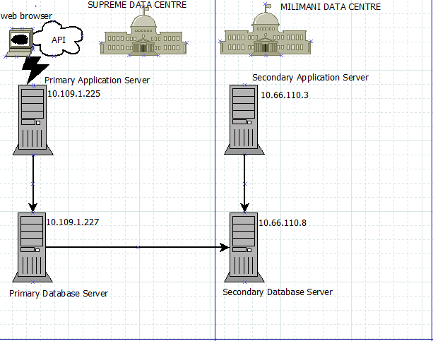

## User Documentation

A detailed and comprehensive user manual will be provided upon the completion of this project. It will provide detailed instructions on how to execute all supported functionality in the system. There will also be screen shots of the various processes contained in the manual. This is to assist in making this easier to understand and use.

## User Interfaces

### Intuitive Design

The system’s interface will be designed to be as easy to use and understand as possible for the user. The system navigation controls will be located at the top of the page. It will contain all the navigation links for all the pages a user can access. However, there will be some pages that can only be accessed through the edit sections of specific records. This will only apply for child pages that serve to provide more details about a specific record. Pop-ups will bring up forms that will enable you to add new records, edit existing records, and view the details about selected records and to confirm the deletion of records.

### Responsive web design

Responsive web design allows desktop webpages to be viewed in response to the size of the device one is viewing with. The system will implement responsive layouts in its design. This is to enable users to have a pleasant experience when accessing the system through various access channels such as a laptop, mobile phone or tablet devices.

### Branding

The theme of the system will be that of the Judiciary. The Judiciary’s logo and brand colors will be artistically used in the system to give a pleasant interface that captures the brand identity of the judiciary.

### Communications Interfaces

The system is built on recognized standards and open interfaces for easier data exchange. These recognized standards and open interfaces are: -

* REST API endpoints for easier data exchange with other systems via JSON/JSONB and XML.
* HTTPS with 128bit SSL encryption for secure data transfer.
* HTML 5 and CSS3 technologies have been used ensure standard web page rendering.
* OpenID connect and OAuth 2.0 access control standards have been used for secure system authentication and authorization.
* SVG for dashboard rendering
* Media queries to enable responsive user interface design.

# Functional Requirements

### E-case Registration

The Litigants and Advocates will be able to initiate online case Registration from any location ( Office ,Homework ets)

#### Case Registration process

**Presentation of pleadings**

THE PROCESS OF REGISTERING A CASE IN THE COMMERCIAL DIVISION

**The pleadings could be a Plaint, Petition or an Application depending on the nature of the case.**

**The Defendant’s advocate files a Defense**

**The Defendant’s advocate files Notice of Appointment and memorandum of appearance**

**Summons are issued by court to be served to the Defendant**

**During registration, case number is allocated and case details captured in the register. They include; parties, nature of claim, court fees paid and the receipt number**

**Once the pleadings close, Case Management Conference is conducted to confirm compliance**

**Notice of appointment and memo of appearance**

**Defense**

**Case Management Conference**

**Summons issued**

**The Plaintiff / Applicant makes payment into Judiciary account**

**The cashier issues a serial number on the deposit slip**

**Payment**

**Assessment is done as per the fee guide provided**

**Registration**

**Issuance of serial number**

**Assessment of Court Fees**

#### Process for application/ Procedure for filing Applications

Interim Orders sought granted

Ruling

Application not brought under Certificate of urgency

Hearing of the main Application

Orders sought not granted

Applications brought under Certificate of Urgency

Party extracts Court Order

Court Order served

**Notice of Motion/ Chamber Summons**

Parties are free to make Applications at any stage of the suit as it may deem necessary. If the Applications are urgent, the same are brought under Certificates of urgency

#### E-case Registration context Diagram & Fields

**Case registration**

Case Number

Case Code

Law Firms

Court station

Case Type

Appeal Case Number

Case Status

Date of Filling

Parties Info

### Electronic Document Submission

Litigants and Advocates will be able to file/ submit documents online to the Judiciary Registry

The following is the list of examples of documents to be electronically filed.

1. Case initiation documents e.g. plaint, charge sheet, petition, originating summons, petition, cause, witness statements, miscellaneous applications, memorandum of appeal for appeals etc
2. Notices of appearance by parties
3. Replies by parties against whom complaint is made
4. Court proceedings and orders
5. Evidence presented in Court – exhibits
6. Exhibit photographs
7. Security documents, log books, title deeds, pay-slips and an introduction letter from the employer, identification cards, colored passport size photographs, official search for the documents, official search receipt, valuation report etc

#### E-Documents Context Fields

Document Owner

Document Name

Document Category

Court Evidence

Case Initiation Documents

Appearance notices

Description

Security Documents

Complaint Replies

Court Proceedings/Summons

Exhibit Photos

**Documents**

### E-payments

The litigants will be able to make court fee payment online

The module should also accept incoming payment information from a 3rd Party agent via an API connection, process the payment and issue Receipt Numbers back to the Litigants and Advocates/end-user directly or via the 3rd Party.

The system should produce comprehensive and detailed financial reports to Accounts and Finance Department.

#### E-payments Context Diagram & Fields

**Court Fees**

Payment Type

Payment Method

Amount Assesed

Amount paid

Date

Payer Name

#### E-payment Process flow

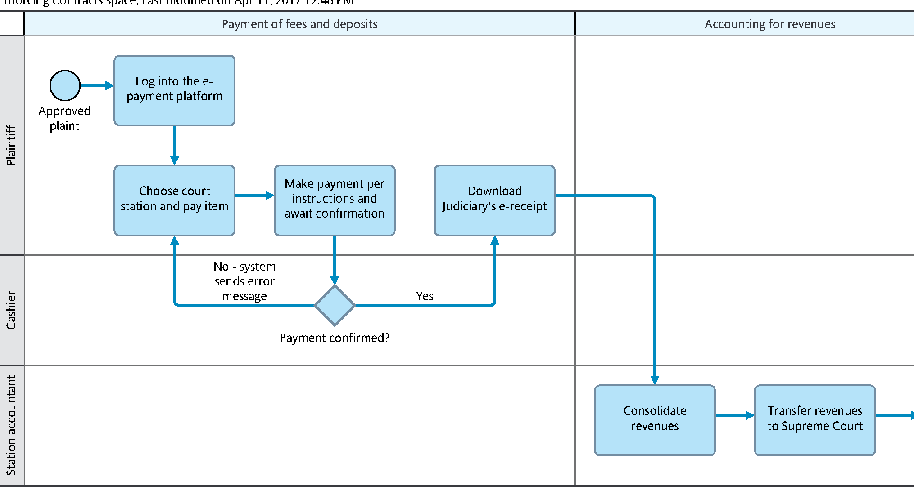

### E-Correspondence

There will be a platform for constant communication by the litigants and the Judiciary via the E-filing system

All Communications between the Litigants and the E-filing server must be encrypted. Encryption of communications will ensure that anyone packet sniffing over the network will be unable to extract any usable information from the data that is being sent between the Litigants and Advocates and the server.

The System users will automatically be log out if there is no activity for three minutes

### E-Service

Where applicable the Litigants will have a platform to serve Summons case parties online

### System Users & Roles

| **SN** | **USER** | **TASK DESCRIPTION** |
| --- | --- | --- |
|  | Presiding Judge | * Empaneling * Overall Coordination |
|  | Judge/Magistrate | * Their key role is to access the system to view case details and associated documents attached. * The Judge/Magistrate will continuously sensitize advocates and litigants on the eFiling system. |
|  | Deputy Registrar | * Oversight of the e-filing process * The DR is the administrator of the system i.e.   Approves adding of users/staff to the system.  Approves access rights and privileges.  Allocates Judges/Magistrates to a case |
|  | Executive Officer | Daily Supervision of the e-filing process |
|  | Court Clerk | Data entry in the court room  Scanning of case documents |
|  | ICT Officer | Ensures that the e-filing system is up and running. |
|  | Registry Staff | * Access the system in response to incoming eFiling request. * Interact with litigants and advocates on the eFiling portal. * Scan incoming files at the registry. * Sensitize the advocates and litigants on eFiling |
|  | Advocates &Litigants | * Files Cases and Make Payments * Registration / creation of accounts on the eFiling portal i.e both individuals and firms. * Sensitize staff in their firms on the use of the system. * Access and use the eFiling system for case filing |

# DESIGN PROPOSAL

### Maintainability

The software will be well documented and it will be designed to be modular. The use of object Oriented programming will help also help increase maintainability .This will make it easier for future developers to make changes and updates to the software with a minimum amount of effort

### Scalability

Both the E-filing system and this document are meant to be easily scalable to increase the scope and the number of Court covered. All efforts will thus be made to use a software design that does not have built limitations

## GUI Design Model

### LoginPage

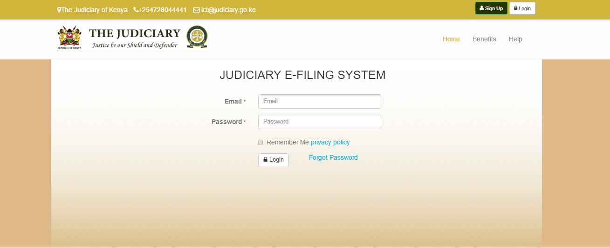

### Registration of NEW LAW FIRM

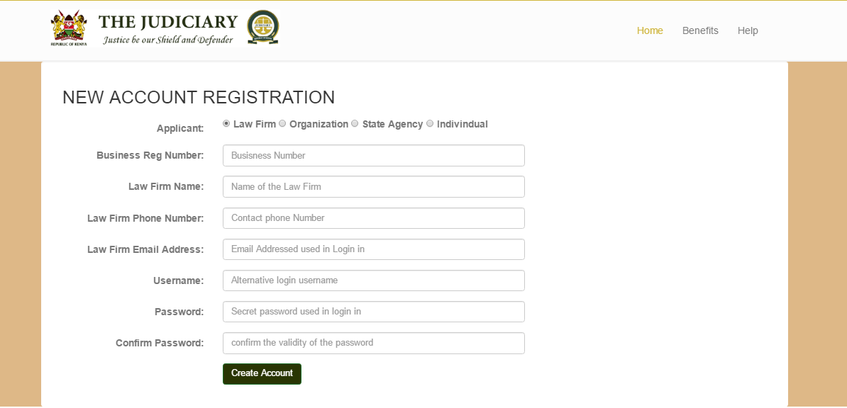

### Dashboard

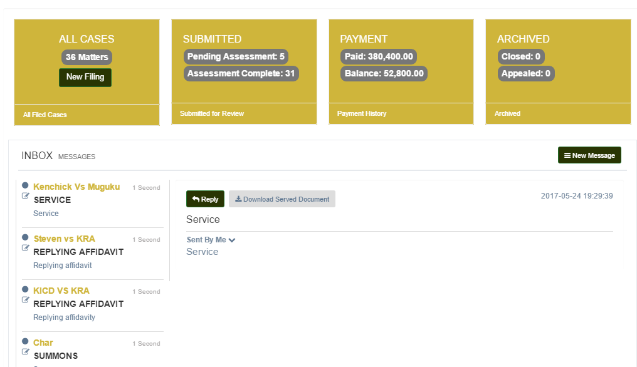

### E-Communications

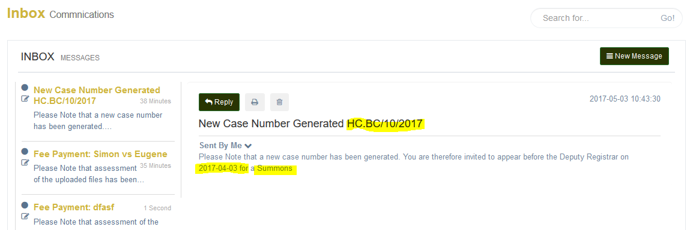

### Filing a New Case

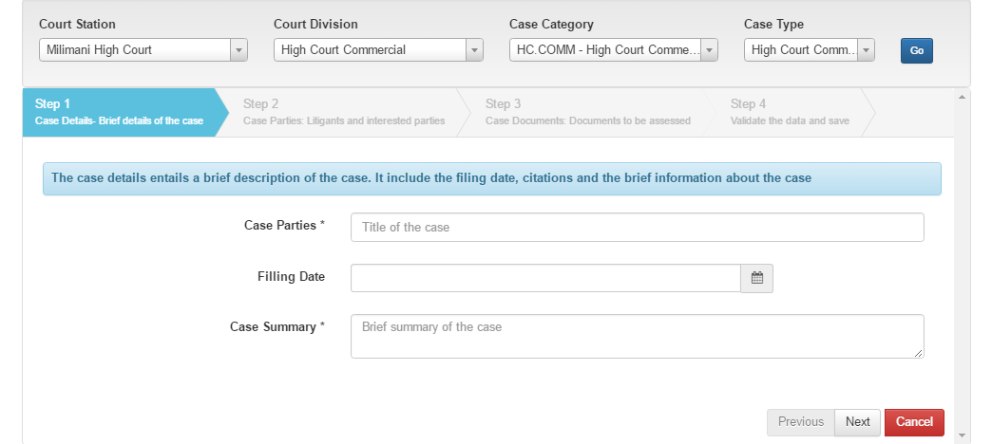

### ADDING PARTIES

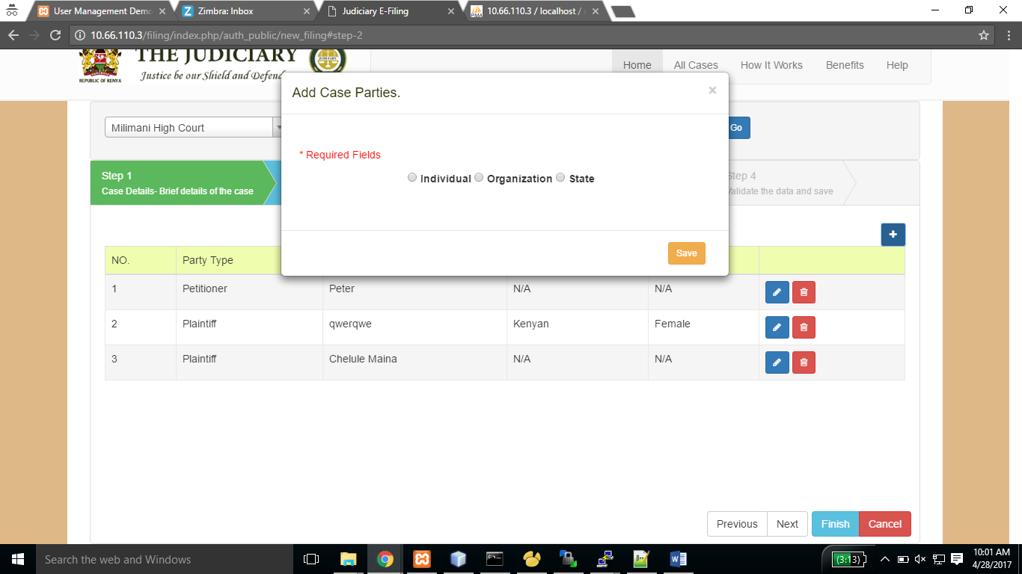

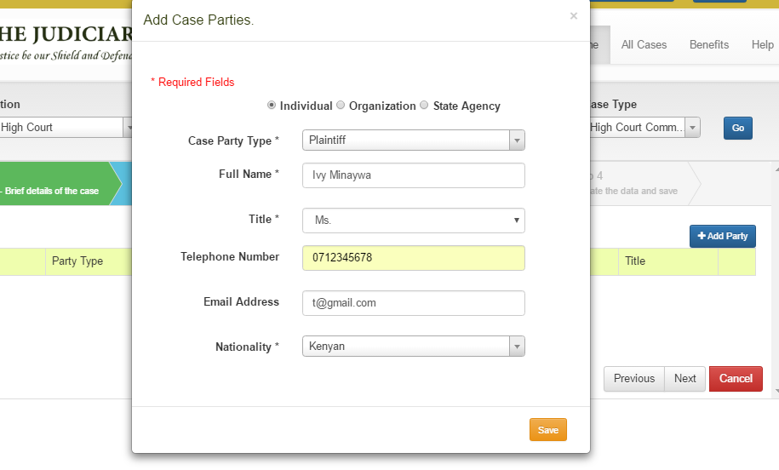

### Uploading Documents

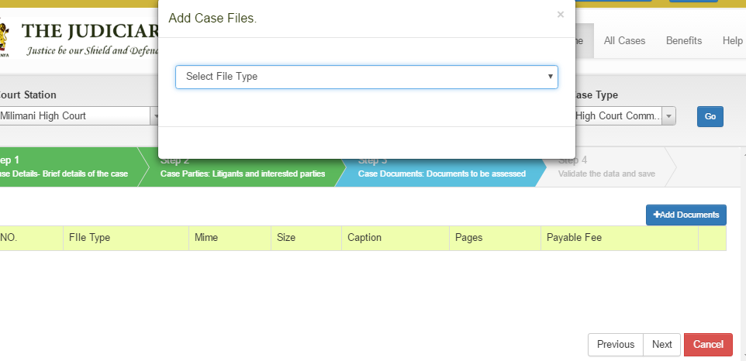

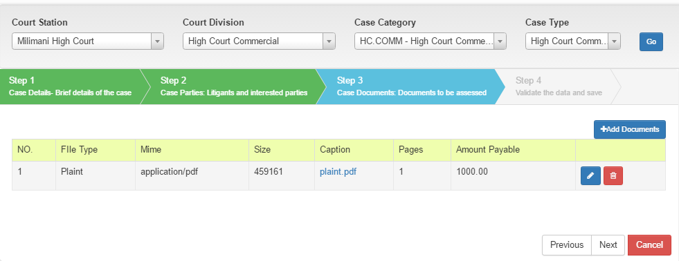

### Making Payments

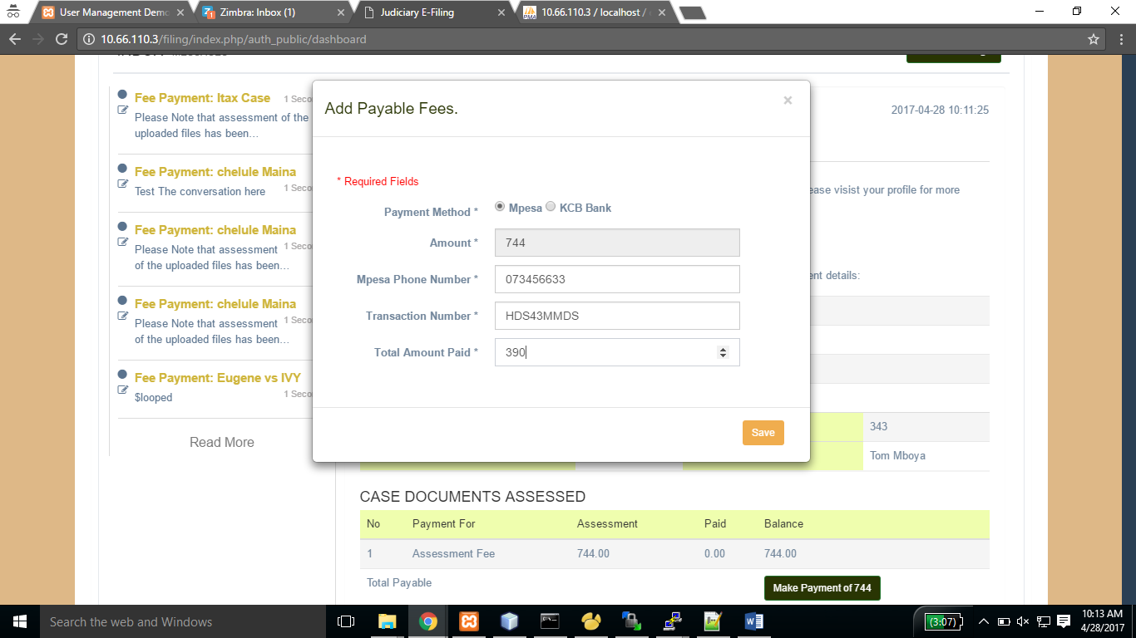

# Non Functional Requirements

### Software Quality Attributes

The system has the following additional characteristics:

* Availability – they system will be available offline and online whenever needed. Users will be able to access it from anywhere.
* Correctness – The system will be able to provide accurate and correct reports and analysis based on the accuracy and correctness of the data fed to it. Garbage in, Garbage out.
* Flexibility – The system will be designed in a way that enable sit to adapt to possible or future changes in its requirements.
* Maintainability – The system will be designed in such a way that ensures a 90% maintainability for 1 hour. i.e. There is a 90% probability that any faulty components or reported errors will be repaired within an hour of reporting.
* Usability – By making use of intuitive and responsive user interface design principles, the system will be designed to ensure an ease of use and ease of learning.

### Testing

A test plan will be developed from the onset of design to ensure that testing is not an afterthought. The development team will automate testing by writing software to test all of the components of the system. Some testing will also be done manually. Tests and their results will be documented. The following test classes will be considered necessary:

### CodeReviews

The development team will have scheduled code reviews to continually reexamine each other’s work and detect problems as soon as possible, before new components are integrated into the system.

### Functional Testing

To check that the software will what it should under normal conditions, the development team will run through as many user scenarios as possible

### System Stress Testing

Tests that cause the system to exceed the specified limits of RAM, CPU, and hard disk space will be run to ensure that the system fails safely.

### Security Testing

#### Denial of Service Attacks

The development team will subject the Server to denial of service attacks to ensure that the E –filing can be properly shut down and restarted in the exact state that it left off.

### Regression Testing

The development team will continually test the system at all stages of production in order to ensure that it is fully functional. All errors and malfunctions reported in the software testing process will be documented and tested with each new addition or release of the software.

### Recovery Testing

Tests will be run to ensure that the state of E-filing can be completely restored if a power failure occurs or the E-filing Server is shut down.

### White Box Testing

During the design phase of the software, the development group will be creating white box test plans. These plans will involve writing extra components to test the internal structures of the software.

### Legal / Legislations considerations

The legislation that support this process has been outlined below this include they are summarized as shown below

1. Constitution Article 260
2. Kenya Information and Communication Act, No. 2 of 1998
3. Civil Procedure Act, Cap. 21
4. Evidence Act, Cap. 80
5. Legal Aid Act, No. 6 of 2016
6. Judicial Service Act, No. 1 of 2011

#### Constitution

Article 260 (the interpretation article) which provides that the word “document” includes electronic files.

Article 25(c) provides that the right to a fair trial cannot be limited. This right includes the right to have a trial begin and conclude without unreasonable delay as set out in Article 50(2)(e). One way of ensuring this would be through e-filing as the documents would not be misplaced/misfiled or lost once they are e-filed.

#### Kenya Information and Communication Act, No. 2 of 1998

Section 2 defines “e-Government services” as “public services provided electronically by a Ministry or Government department, local authority, or any body established by or under any law or controlled or funded by the Government”. This section therefore permits the Judiciary to commence e-filing.

Section 83S provides for the use of electronic records and electronic signatures in Government and its agencies. In particular, paragraph (b) refers to “the filing of any form, application or any other document with any office, authority, body or agency owned or controlled by the Government in a particular manner”. This therefore can include electronic filing of case documents.

#### Civil Procedure Act, Cap. 21

Section 3 on saving of special jurisdiction and powers provides that “in the absence of any specific provision to the contrary, nothing in this Act shall limit or otherwise affect any special jurisdiction or power conferred, or any special form or procedure prescribed, by or under any other law for the time being in force.” It can therefore be argued that sections 2 and sections 83S of the Kenya Information and Communication Act gives the Judiciary that special power to introduce electronic filing.

Section 19 on institution of suits provides that “every suit shall be instituted in such manner as may be prescribed by rules. Rules could therefore provide for electronic filing.

#### Evidence Act, Cap. 80

Section 106B on admissibility of electronic records provides that “…any information contained in an electronic record which is printed on paper, stored (my emphasis), recorded or copied on optical or electro-magnetic media produced by a computer (herein referred to as “computer output”) shall be deemed to be also a document, if the conditions mentioned in this section are satisfied in relation to the information and computer in question and shall be admissible in any proceedings…” This section supports electronic filing as information stored is recognized as a document.

#### Legal Aid Act, No. 6 of 2016

Paragraph (b) of subsection 2 requires the Legal Aid Service to ensure that the the register of accredited legal aid providers “is available in electronic form or other accessible formats”. This goes to show that electronic filing of case documents is an acceptable means for the Judiciary to keep its records in an accessible format.

#### Judicial Service Act, No. 1 of 2011

Paragraph 23 of Part III on the application of the Second Schedule provides that notes before a Tribunal set up for the purposes of removing a judge may be electronically recorded.